**1. ABOUT THE COMPANY**

**1.1 Brief History**

Founded by a team of young, dynamic and experienced professionals, TAKE IT SMART (OPC) PVT.LTD. is a locally own company with the people having collective experience for more than decades. TAKE IT SMART (OPC) PVT.LTD is a leading solution provider for e-business Enabling, Solution Consultancy, Turn-key Solution and Post Implementation and Customized Support and also providing integration of enterprise solution to open platform standards e business solution. Time to market, quality of work and value adding to our customer’s requirements are our key focus in all our deliveries The Company serves a worldwide client base. All offices employ an experienced team of professionals, with an outstanding track record of handling complex web & Apps development projects. TAKE IT SMART (OPC) PVT.LTD prides itself on delivering products and services which adhere to the principles of quality, transparency and affordability. We provides solutions to a range of players in the All sector in India At TAKE IT SMART, we see our customers as our Business Partners, We are proud each time we created a satisfied customer.

**1.2 Vision Mission**

**Mission**

* To accelerate the development of products and reduce time to market through its proven processes, methodologies and tools.
* Providing turnkey Engineering solutions to the customers in the field of Electronics.

**Vision**

* With the mantra of inspiring world and empowering minds, we aim to be a key Innovative Product designer and developer with Zero Tolerance.

Our Vision to provide ONE STOP IT SOLUTIONS for all Business Requirements. Our Team Make up of a team of young dynamic and experience professional. The team is enriched with unique domain knowledge, which span from Info Technology, Design and Creative, Retail & Wholesaling, Travel & Tourism industry, Insurance & Finance, Manufacturing, and Public Sector etc. Our Track Record The TAKE IT SMART (OPC) PVT.LTD Team has served customers across all verticals. The team has collective experience with both private and public sectors

**1.3 major milestone**

Hybrid apps get trained for industry requirements while you pursuing degree The Different Internship¬verticals that we operate in are: Software Training College Projects

* Workshops
* Seminars
* On Job Training
* Faculty Development Programs
* Corporate Training
* Training and Placements Programs
* Corporate Training/Training and Placement.
* Consultancy
* Product Development
* Mentor Zone
* Testing
* Online Trainings

**1.4 Products and Services**

* 1. Lab Equipments/ Educational Board
* 2. Software services
* 3. Development Board
* 4. Academic Projects
* 5. Training and Placement
* 6. Research & Development

**1.4.1 Lab equipments/ educational board**

In the manufacture of Microprocessor Trainers and Interface Boards. With the efforts from our Research and Development Team, the company has expanded its activities in various areas as follows. Microcontroller, Process Control Instrumentation, Digital Signal Processing

Power Electronics & Drives, Data Acquisition Systems, Personal Computer Trainer Systems etc. At present, the company is concentrating in various new fields like Advanced Control Systems, Solar Heat Pump Trainers, Advanced Process control, Chemical Reactors, Distillation Column, Image Processing, Nuclear Electronics, Defense projects etc.,

**1.4.2 Software Services**

The provide a software service in the area of software development, mobile app development, and digital marketing, in Electronics and communication, Computer Science, and Mechanical with advance tools as required by the customer, college and industry needs.

**1.4.3 Development boards**

**Development board** is a printed circuit board containing controller and the minimal support logic needed for an engineer to become acquainted with the microprocessor on the board and to learn to program it. It also served users of the microprocessor as a method to prototype applications in products. Like Microcontroller, FPGA and PCBS

**1.4.4 Academic Projects**

* **B.E/B.Tech** – EEE, ECE, TCE, CSE, IT, MECH.
* **M.E/M.Tech** – P.E&D, Power Systems, Java, Embedded Systems, Digital Signal Processing, Digital Electronics and Communications, Applied Electronics, CSE & MCA, Diploma – DEEE, DECE, DCSE,

**1.4.5 Training and Placement**

This Institute offers 24-Week Advanced Course in Embedded Systems. This course is designed to offer application oriented training & real time exposure to students, there by provides for bridging the gap between industry’s requirements and students’ academic skill set. By pursuing the Institute’s Program in Embedded Systems the students gain ready acceptance in the market.

Institute’s Advanced Course in Embedded systems serves the interests of practicing embedded software engineers as well as those engineers planning to enter the embedded field. The course content of this Program is approved by the industry and it,

* Presents practical lessons and techniques for use in Designing, Implementing, Integrating and Testing software for Modern Embedded Systems
* Describes what an embedded system is, what makes them different, and what embedded systems designers need to know to develop embedded systems
* Provides the student with a life cycle view for designing multi-objective, multi-discipline embedded systems
* Imparts a solid understanding of the role of embedded systems and embedded systems design and development in modern day’s technology-enabled society

**1.4.6 Research & Development**

**(R&D) in** Power Electronics, Communication, VLSI, Management, Image Processing, Surveillance System, Computer Science, Information Technology, Bio-Medical and Management. R&D unit is specially managed by most experience Doctorates.

**1.5 Operation of Company**

* **EMBEDDED SYSTEM**

[](http://www.innovetech.in/embedding.html)An embedded system is some combination of computer hardware and software, either fixed in capability or programmable, that is specifically designed for a particular function. Industrial machines, automobiles, medical equipment, cameras.

* [**Web Design& Maintenance**](http://www.techkshetrainfo.com/web.html)

Web design is the process of creating websites. It encompasses several different aspects, including webpage layout, content production, and graphic design. While the terms web design and web development are often used interchangeably, web design is technically a subset of the broader category of web

* [**Domain Register & Hosting**](http://www.techkshetrainfo.com/domain.html)

A **domain name registrar** is an organization or commercial entity that manages the reservation of [internet](https://en.wikipedia.org/wiki/Internet) [domain names](https://en.wikipedia.org/wiki/Domain_name). A domain name registrar must be accredited by generic (gTLD) [registry](https://en.wikipedia.org/wiki/Domain_name_registry) and/or a [country code top-level domain](https://en.wikipedia.org/wiki/Country_code_top-level_domain) (ccTLD) registry. The management is done in accordance with the guidelines of the designated [domain name registries](https://en.wikipedia.org/wiki/Domain_name_registry).

* **CLOUD COMPUTING**

Cloud computing, also known as on-demand computing, is a kind of internet-based computing, where shared resources and information are provided to computers and other devices on-demand. It is a model for enabling ubiquitous, on-demand access to a shared pool of configurable computing resources.

* 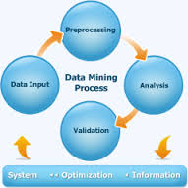**DATAMINING:**

Data mining is an interdisciplinary subfield of computer science involving processes of data set discovery utilizing intersecting methodologies (artificial intelligence, machine learning, statistics, and database system(s) etc. The overall goal of the data mining process is transformative structural application(s). Aside from the raw analysis step, it involves database and data management aspects, data pre-processing, model and inference considerations, interestingness metrics, complexity considerations, post-processing of discovered structures, visualization, and online updating.

* 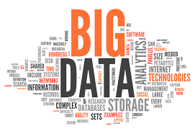**BIG DATA**

'Big data is a broad term for data sets so large or complex that traditional data processing applications are inadequate. Challenges include analysis, capture, data curation, search, sharing, storage, transfer, visualization, and information privacy. The term often refers simply to the use of predictive analytics or other certain advanced methods to extract value from data, and seldom to a particular size of data set. Accuracy in big data may lead to more confident decision making. And better decisions can mean greater operational efficiency, cost reduction and reduced risk.

**1.6 Organization Structure of the Company**

|  |  |
| --- | --- |
| Name | TAKE IT SMART |
| Registration | TAKE IT SMART (OPC) PVT.LTD. |
| Company Logo | logo1.jpeg |
| Foundation Logo | logo.jpeg |
| Tag line | *Quick and Relible Soulations* |
| Founder | Mallikarjun Kumbar (8050104212)  Naseema Hubballi(8792697647) |
| Establishing Year | 2020 |
| Website | www.takeitsmart.in |
| Email | info@takeitsmart.in |
| Products | • Embedded Systems • Raspberry Pi IoT Engineering Electronics• Engineering Embedded Firmware Development Robotics (Electronics)• ARM, AVR, RENESAS,• PIC Microcontrollers Embedded Software (Raspberry Pi• & AI) Embedded C Development• PYTHON MACHINE LEARNING AND ARTIFICAIL INTELLIGENCE• PROTOCOLS I2C, SPI etc |
| Affiliations | Karnataka, |
| Registered and Verifying Authority | Govt. of Karnataka INDIA |
| Branches Address | #1274, 2nd Floor Sanitary core, 3rd phase Yelahanka New Town, Bengaluru-56006 |

**2. TASK Performed**

**2.1 Technical Activities**

There are four main factors responsible for intensity change in an image. Geometry, illumination, reflectance and viewpoint. The purpose of the early vision process is to sort out which changes are due to which factor. It is essential to develop 9 methods to identify changes of a specific kind. Needless to say those changes due to geometry (edges of objects) are of greater interest while responses due to other factors are of little or no interest and should be suppressed.

**Objective of the Task**

The proposed to compare the most widely used edge detection techniques and to develop a new technique for edge detection. For this purpose literature survey of various edge detection techniques was done and three techniques were selected for implementation i.e., LoG, Canny's edge detector and First derivative method.

**2.2 PROGRAMMING LANGUAGE SELECTION**

We studied about the python and Machine learning, we used the software’s like python interpreter. How to run application that runs on the thonny IDE Currently.We use different type of libraries like :

Numpy, Matplot, Opencv,

**2.3 task assigned**

The ultimate goal of edge detection is the characterization of intensity changes in the image in terms of physical process that originated them. The edge operators may include any or all of the following:

1.).Magnitude of the edge.

2.) Direction of the edge.

3.) Reliability of the edge description.

4.) Width or blur.

The most simple edge detector is an arbitrary thresholding of gray level values at a certain constant to formulate a binary image. In a binary image all pixels have a value either 1 (white) or 0 (black). Thus, all pixels which have a gray level value larger than the threshold will be assigned the value 1, and the rest will have the value 0.

The edges are formed by the boundaries between the black and white regions. The main problem in devising an edge detector is that edges are a high frequency phenomenon and so is the noise in the image. To avoid detecting noise as edges a low pass filter or a large (in spatial extent) operator is used to average out the noise. But this operation also averages out the edges and is likely to form a single averaged edge from several neighboring edges. Consequently, this degrades the position accuracy of the detected edges.

Edge detectors should be formulated for different contexts. The requirements of many situations are similar and it is possible to design one edge detector for several contexts. The most important step in design of such a detector should be the specification of performance criteria. The edge detector accepts discreet digitized images and processes an "edge map" as its output. The edge map includes information about the position, strength and orientation of edges

**2.4 OVERVIEW of tools and technologies used**

The computer vision literature is flooded with articles describing edge detectors. Many different techniques for edge detection are discussed in the technical literature and text books on machine vision and scene analysis. This describes some of them. There are two major classifications of edge detectors as listed below:

1. Edge detectors based on first or second derivatives as appropriate quantities to characterize step edges.

2. Edge detectors based on image support approximation by a set of basic functions and edge parameters

**tools and technology**

We used the software’s like python interpreter. How to run application that runs on the thonny IDE Currently. We use different type of libraries like:

Numpy: It is a general-purpose array processing package which provides tools for handling the n-dimensional arrays. It provides various computing tools such as comprehensive mathematical functions, linear algebra routines.

Matplotlib: Ii is an amazing visualization library in Python for 2D plots of arrays

Opencv: It is a huge open-source library for computer vision, machine learning, and image processing.

**3. reflection notes**

**3.1 Learning Goals**

Experience at the company satisfactory, the people works in co-ordination and the company environment is very safe and studious. The reason to choose this company was that it was offering internship in wireless which is my core specialization in PG degree and I wanted to benefit from this experience, also I got to learn new tools like machine learning with python

I used to spend nearly 5 to 6 hours daily in the company trying out with different circuits and make their layout manually. I think my guide who was always there by my side throughout my internship process giving me advice, feedback and tips on how the people work in an industry environment.

On the whole, this internship was a useful experience. I have gained new knowledge, skills and met many new people. Internships help us to learn more about our self.  Through an internship, we come to know clarity on our strengths, weaknesses, and interests.

Internships increase our professional confidence and also improve our communication skills. Through an internship, we get a chance to learn what it is really like to work in a company, in an industry, and in various job functions. Internships help us to develop better work habits and learn how to manage tasks/projects and learn how to carry our self in a professional environment. We can also learn from our colleagues by observing their positive and negative work habits.

**3.1.1 NON-TECHNICAL OUTCOMES**

* Developed analytical skills
* Developed problem solving skills
* Improvement in verbal and written communication skills
* Effective utilization of resources
* Effective time management
* Loss of stage fear
* Learnt the methods of writing technical articles
* Improvement in presentation skills
* Personality development
* Learnt the importance of team work and group discussions
* Better coordination and interaction with people
* Stress management
* Exposure to innovative ideas.

**3.2 NON-TECHNICAL SKILLS**

* Procedure to be followed to apply technical papers for several conferences
* Method of preparing technical papers
* IEEE format for technical papers
* Improved oral and written communication
* How to face the crowd
* Overall personality development
* How to interact with people
* Improved level of confidence
* Method of paper presentation
* Improved typing speed.

**3.2.1 INTERPERSONAL SKILLS**

[Interpersonal skills](http://www.investopedia.com/terms/i/interpersonal-skills.asp) influence business cultures because they affect job performance, which in turn helps to decide the outcome of a company's success. Interpersonal skills include interaction with others, good communication skills, listening skills and attitude. Companies should realize that interpersonal skills are not learned in a classroom; rather they are characteristics that an individual may possess naturally.

Interpersonal skills allow people to communicate effectively, handle conflicts and respond to others' needs accordingly. In an ever-changing job market, these skills teach workers and business owners how to be agile, solve complex problems, perform critical thinking on their feet and manage diverse relationships both internally and externally. Measuring a potential employee's ability to interact with others in a respectful and appropriate manner determines how we likely to thrive in a team-oriented environment.

Some of the major factors that make up a person's interpersonal skills are diplomacy, helpfulness, optimism, influence and flexibility. Also vital arecollaboration skills, empathy, tolerance and frankness. These characteristics often align with [corporate culture](http://www.investopedia.com/terms/c/corporate-culture.asp) as well as small business culture.

Ways to improve interpersonal skills include touring different sites, managing by walking around, arranging lunches and corresponding consistently via phone or email. Having good interpersonal skills promotes approachability, likability and comfort. Managers who possess strong interpersonal skills motivate their staff to challenge themselves and do a better job. Most importantly, they make workers feel as if they can go to their bosses with any problems or concerns.

Both verbal and non-verbal interpersonal skills are extremely important when it comes to a company's success. When you can speak to people in an articulate manner, you avoid communication errors and are more likely to have happy customers. It's just as important to maintain the correct tone of voice as well. Non-verbal communication consists of facial expressions, hand gestures and body language. It can also determine whether or not your interaction results in a satisfied customer. When you combine both verbal and non-verbal skills, the result is a powerful demeanor that may help to determine the success of a company. In addition; superb interpersonal skills encompass listening skills, problem-solving, decision-making and negotiation skills. The ability to communicate internally with employees and coworkers is just as important as building and maintaining solid relationships with customers.

**3.2.2 PERSONALITY DEVELOPMENT**

Personality development grooms an individual and helps to make a mark of them self’s in society. Individuals need to have a style of their own for others to follow them. Do not blindly copy others. We need to set an example for people around. Personality development not only looks us good and presentable but also helps us to face the world with a smile.

Personality development goes a long way in reducing stress and conflicts. It encourages individuals look at the brighter side of life Personality development helps us to develop a positive attitude in life. An individual with a negative attitude finds a problem in every situation. It is essential for individuals to behave well with people around. Being polite with others will not only make an individual popular among other people, but also helps to earn respect and pride.

Personality development helps us to differentiate our personal and professional life. It is really essential to keep a balance between both the lives to lead a peaceful and stress free life. Personality development helps an individual to inculcate positive qualities like punctuality, flexible attitude, willingness to learn, friendly nature, eagerness to help others and so on.

**Theoretical Understanding**

The basic steps involved in this algorithm are:

* Noise reduction using Gaussian filter
* Gradient calculation along the horizontal and vertical axis
* Non-Maximum suppression of false edges
* Double thresholding for segregating strong and weak edges
* Edge tracking by hysteresis

Now let us understand these concepts in detail:

**1. Noise reduction using Gaussian filter**

This step is of utmost importance in the Canny edge detection. It uses a Gaussian filter for the removal of noise from the image, it is because this noise can be assumed as edges due to sudden intensity change by the edge detector. The sum of the elements in the Gaussian kernel is 1, so, the kernel should be normalized before applying as convolution to the image. In this tutorial, we will use a kernel of size 5 X 5 and sigma = 1.4, which will blur the image and remove the noise from it. The equation for Gaussian filter kernel is

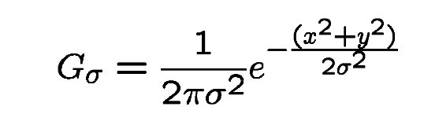

**2. Gradient calculation**

When the image is smoothed, the derivatives Ix and Iy are calculated w.r.t x and y axis. It can be implemented by using the Sobel-Feldman kernels convolution with image as given:  
 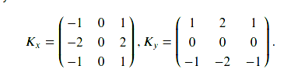

*Sobel Kernels*

after applying these kernel we can use the gradient magnitudes and the angle to further process this step. The magnitude and angle can be calculated as  
 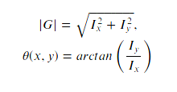

*Gradient magnitude and angle*

**3. Non-Maximum Suppression**

This step aims at reducing the duplicate merging pixels along the edges to make them uneven. For each pixel find two neighbors in the positive and negative gradient directions, supposing that each neighbor occupies the angle of pi /4, and 0 is the direction straight to the right. If the magnitude of the current pixel is greater than the magnitude of the neighbors, nothing changes, otherwise, the magnitude of the current pixel is set to zero.

**4. Double Thresholding**

The gradient magnitudes are compared with two specified threshold values, the first one is lower than the second. The gradients that are smaller than the low threshold value are suppressed, the gradients higher than the high threshold value are marked as strong ones and the corresponding pixels are included in the final edge map. All the rest gradients are marked as weak ones and pixels corresponding to these gradients are considered in the next step.

## 5. Edge Tracking using Hysteresis

Since a weak edge pixel caused by true edges will be connected to a strong edge pixel, pixel W with weak gradient is marked as edge and included in the final edge map if and only if it is involved in the same connected component as some pixel S with strong gradient. In other words, there should be a chain of neighbor weak pixels connecting W and S (the neighbors are 8 pixels around the considered one). We will make up and implement an algorithm that finds all the connected components of the gradient map considering each pixel only once. After that, you can decide which pixels will be included in the final edge map.  
Below is the implementation.

Installing Thonny IDE – Windows PC

To install Thonny on your Windows PC, follow the next instructions:

**1.** Go to [https://thonny.org](https://thonny.org/)

**2.** Download the version for Windows and wait a few seconds while it downloads.

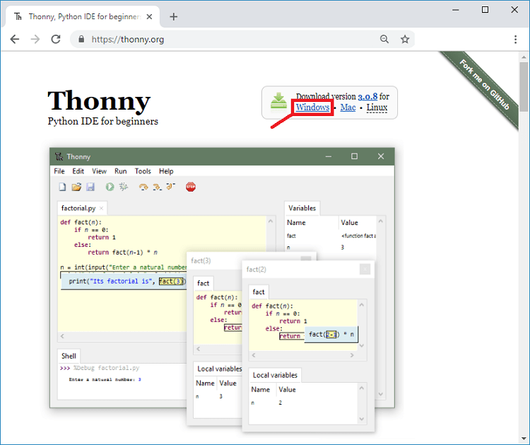

Run the *.exe* file.

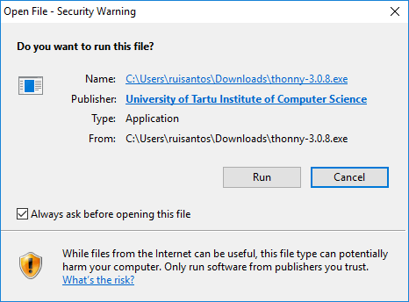

**4.**Follow the installation wizard to complete the installation process. You just need to click “Next”.

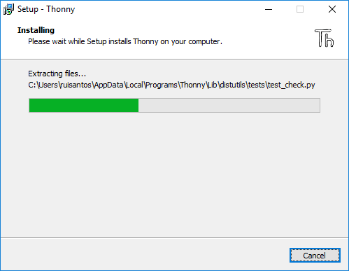

**5.** After completing the installation, open Thonny IDE. A window as shown in the following figure should open.

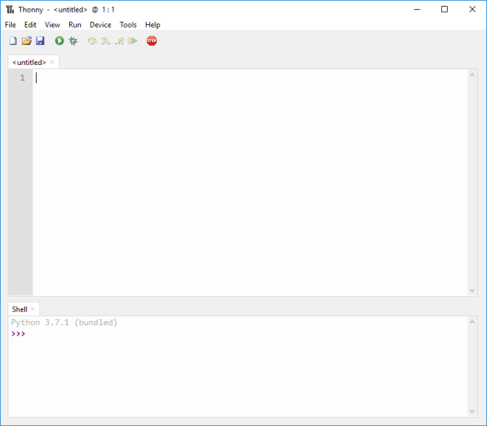

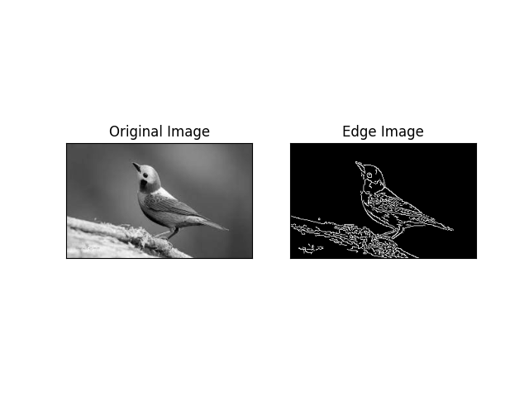

**CONCLUSION AND FUTURE WORK**

The Canny algorithm is adaptable to various environments. Its parameters allow it to be tailored to recognition of edges of differing characteristics depending on the particular requirements of a given implementation. In Canny’s original paper, the derivation of the optimal filter led to a [Finite Impulse Response](https://en.wikipedia.org/wiki/Finite_Impulse_Response) filter, which can be slow to compute in the spatial domain if the amount of smoothing required is important (the filter will have a large spatial support in that case). For this reason, it is often suggested to use Rachid Deriche's [infinite impulse response](https://en.wikipedia.org/wiki/Infinite_impulse_response) form of Canny's filter (the [Canny–Deriche detector](https://en.wikipedia.org/wiki/Deriche_edge_detector)), which is recursive, and which can be computed in a short, fixed amount of time for any desired amount of smoothing. The second form is suitable for real time implementations in [FPGAs](https://en.wikipedia.org/wiki/FPGA) or [DSPs](https://en.wikipedia.org/wiki/Digital_signal_processor), or very fast embedded PCs. In this context, however, the regular recursive implementation of the Canny operator does not give a good approximation of rotational symmetry and therefore gives a bias towards horizontal and vertical edges.

**REFERENCES**

* Canny, J., [*A Computational Approach To Edge Detection*](http://citeseerx.ist.psu.edu/viewdoc/download?doi=10.1.1.420.3300&rep=rep1&type=pdf), IEEE Transactions on Pattern Analysis and Machine Intelligence, 8(6):679–698, 1986.
* R. Deriche, [*Using Canny's criteria to derive a recursively implemented optimal edge detector*](http://citeseerx.ist.psu.edu/viewdoc/download?doi=10.1.1.476.5736&rep=rep1&type=pdf), Int. J. Computer Vision, Vol. 1, pp. 167–187, April 1987.
* [Lindeberg, Tony "Edge detection and ridge detection with automatic scale selection", International Journal of Computer Vision, 30, 2, pp 117—154, 1998. (Includes the differential approach to non-maximum suppression.)](http://kth.diva-portal.org/smash/record.jsf?pid=diva2%3A452310&dswid=-7063)
* [Kimmel, Ron and Bruckstein, Alfred M. "On regularized Laplacian zero crossings and other optimal edge integrators", International Journal of Computer Vision, 53(3):225–243, 2003. (Includes the geometric variational interpretation for the Haralick–Canny edge detector.)](https://www.cs.technion.ac.il/~ron/PAPERS/laplacian_ijcv2003.pdf)
* [Moeslund, T. (2009, March 23). Canny Edge Detection. Retrieved December 3, 2014](https://web.archive.org/web/20150421090938/http:/www.cse.iitd.ernet.in/~pkalra/csl783/canny.pdf)
* Thomas B. Moeslund. Image and Video Processing. August 2008
* [Green, B. (2002, January 1). Canny Edge Detection Tutorial. Retrieved December 3, 2014](http://dasl.mem.drexel.edu/alumni/bGreen/www.pages.drexel.edu/_weg22/can_tut.html); archived [here](https://web.archive.org/web/20160324173252/http:/dasl.mem.drexel.edu/alumni/bGreen/www.pages.drexel.edu/_weg22/can_tut.html)